|  |  |  |
| --- | --- | --- |
|  | Mount Douglas Secondary School **Scholarship Information Handbook** |  |
|  |  |  |



**2019 - 2020**

**Revised September 25, 2019**

|  |  |
| --- | --- |
| Best Quality School Logo transparent lighter Hi Resolution | Mount Douglas Secondary School |

Scholarship Information

This information is designed to provide you with an overview of:

• the variety of scholarships available

• suggestions for searching out scholarships

• scholarship related materials that can be found at Mt. Douglas

## Types of Scholarships

**1. BC EXCELLENCE SCHOLARSHIPS:**

There are 55 BC Excellence Scholarships available to recognize well-rounded B.C. graduates. Winners will have demonstrated community service, both inside and outside their schools, and shown aptitude and commitment to their chosen career paths. They will receive a $5000 scholarship voucher to use for post-secondary tuition.

**Students must be nominated for this scholarship by their school**. See Ms. Bailey in December if

you wish to be nominated. If nominated, the student must submit an application to their school

district or independent school authority, who will forward it to the Ministry of Education

for adjudication by the selection committee. Deadline: February 2020.

Nominees’ applications will be assessed on the following criteria. Nominees must:

* Be in their graduating year, with graduation to occur by August 31 or sooner of the year in which they are nominated
* Have at least a: "B" (73% or above) in their Language Arts 11 final mark "B" average in Grade 11 final course marks that fulfill graduation requirements of Science 11, Math 11 and Social Studies 11, with no more than one "C+" (67% or above) final course mark, (marks lower than “C+” are not accepted)
* Maintain a “B” average in Grades 11 and 12 final course marks required for graduation
* Submit a resume
* Provide two references, one from their community and one from their school
* Provide a written statement (maximum 500 words) describing: What lead them to their community service, volunteer activity, and/or leadership role. What they learned from this involvement. How these skills/experiences will benefit them in their chosen career path

**A student cannot win both a BC Excellence and Pathway to Teacher Education Scholarship.**

**2. DOGWOOD DISTRICT/AUTHORITY AWARDS**:

There are 5500 District/Authority Scholarships distributed across school districts and independent school authorities that recognize graduating B.C. students for excellence in their chosen area of interest or strength. Winners will receive a $1250 scholarship voucher to use towards their post-secondary tuition. These awards are applied for in June. For information and application form see Ms. Bailey (Room 221) in April.

# To win a scholarship, a student must apply and:

# Meet the basic eligibility requirements.

# Meet criteria determined by the local scholarship committee, which requires a student to demonstrate outstanding achievement in any of the following areas:

# Indigenous Languages and Culture, demonstrated at school or in the community.

# Fine Arts (e.g., Visual Arts, Dance, Drama, Music).

# Applied Skills (e.g., Business Ed, Technology Ed, Home Economics).

# Physical Activity (e.g., Athletics, Dance, Gymnastics, not limited to Physical Education).

# International Languages with Integrated Resource Packages (IRPs) or External Assessments, including A.P. and I.B. courses.

# Community Service (Volunteer Activity), which includes demonstration of local and global issues and cultural awareness.

# Technical and Trades Training (e.g., Carpentry, Automotive, Mechanics, Cook Training)

# Fulfill the B.C. graduation requirements of either the 2004 Graduation Program or the Adult Graduation Program by August 31st of the student’s graduating year.

# Have not previously received a District/Authority Award or a District/Authority Scholarship

# 3. BC ACHIEVEMENT SCHOLARSHIPS:

# The top 8000 B.C. graduates with the highest cumulative average based on courses required for graduation (both required and elective) are eligible to receive a $1250 scholarship voucher to use towards their post-secondary tuition. The Ministry will determine recipients based on students’ achievement in Grades 10, 11, and 12 courses that satisfy graduation program requirements (including elective courses). A cumulative average percentage will be calculated and form the basis for awarding the BC Achievement Scholarship.

# Recipients must:

# Meet basic eligibility requirements

# Attain a "B" (73% or above) or better average in their Language Arts 12 course: English 12, Communications 12, Français langue premiere 12, or English 12 First Peoples

# Have no more than one Transfer Standing (TS) or Standing Granted (SG) indicator among course marks used for the calculation of winners, excluding Language Arts 12, which must have a percentage score.

# A student can receive only one BC Achievement Scholarship in their lifetime.

# 4. PATHWAY TO TEACHER EDUCATION SCHOLARSHIP:

# The Pathway to Teacher Education Scholarship (PTES) is awarded to 20 outstanding high school graduates who have demonstrated a commitment and aptitude for a career path in K-12 teaching. Each recipient will receive a $5000 scholarship voucher to use towards tuition in their teaching program at a designated BC post-secondary institution.

# A student cannot win both a Pathway to Teacher Education Scholarship and a BC Excellence Scholarship.

# To apply, please complete the application form found on the Ministry of Education Website and submit it to us along with all required documents by February 2020.

# 5. DISTRICT AND SCHOOL AWARDS:

• District Awards are applied for in June and adjudicated in October. More information and application forms can be obtained by talking to Ms. Bailey in Room 221.

• It is the policy of School District 61 and Mt. Douglas that one student does not “take it all”, however many students do win more than one scholarship as they are eligible for more than one type of award

• Most in school awards do not require an application and are adjudicated in October**.**

**6. UNIVERSITY ENTRANCE AWARDS**:

**UVIC**:

* No application required, based on minimum entrance average of 85%
* Several at $2000 – some may be as much as $6500 renewable for 4 years
* There are additional entrance scholarships requiring online application

**UBC**:

* No application required, the general admission application is looked at
* Academic scholarships for marks only are automatic at various percentages
* An application is required for the over 80 Entrance Scholarships offered by UBC for outstanding academics combined with leadership in many facets of school life

Every university has different requirements and application processes for scholarships. It is important to check the website of each institution frequently to make sure that all requirements are being met.

**7. PRIVATE SCHOLARSHIPS**:

* Can be any amount
* Administered by various donor scholarship committees, unions, foundations, associations and affiliated groups
* You may be asked if you are being sponsored by the school – this means that the organization expects the school to rank students; the school may be asked to limit the number of applicants

**8. RESOURCE CENTRES**:

* You can find information on Scholarships and Universities and Colleges in the Career Centre.
* Many scholarship applications are on-line. These applications are either downloaded or completed on- line for submission. We don’t necessarily get all applications; sometimes just getting the application is part of the vetting process so read all the details of the scholarship carefully. If you need help obtaining an application see Ms. Bailey. There are charts on the board outside the library that outline information and deadlines.
* There are Scholarship resource books in the Career Centre.
* Check out the Scholarship Calendar under Student Info on the Mount Douglas website.

.

_lbsdqn4[1]

**How to Search for Scholarships and Bursaries**

Tuition

Fees

Books

* The Career Centre has print resources for winning scholarships, sports scholarships, financial assistance, loans, etc. Also check the University and College calendars.
* Research Scholarships on the Internet – many sites are listed on the following page. Most Universities and Colleges have a Financial Aid section on their web sites.
* For further scholarship information – see the scholarship information on the bulletin boards outside the Career Centre. Research affiliation scholarships and professional associations. Also consider talking to Ms. Bailey outside of the timetable Scholarship class.
* Find the scholarships that you are eligible for, if you need assistance obtaining an application form please see Ms. Bailey, the career centre secretary or a Counsellor for assistance.
* Keep in mind that deadlines are ***very*** important. Try to send in the application a week prior to the deadline.

|  |  |
| --- | --- |
| **Financial Aid & Scholarships** | **Internet – http://** |
| Association of Universities & Colleges of Canada | www.universitystudy.ca |
| BC Financial Opportunities For Students | www.bced.gov.bc.ca/awards |
| Career Cruising | www.careercruising.com |
| Student Aid BC | www.studentaidbc.ca |
| Student Scholarships.org | www.studentscholarships.org |
| Canada Student Loan | www.canlearn.ca |
| Scholarships Available to BC Students | www.bcscholarships.ca |
| NCSA Athletic Scholarships | www.ncsasports.org |
| Loran Scholars Foundation | http://loranscholar.ca/ |
| FastWeb Canada | www.fastweb.com |
| The Financial Aid Information Page | www.finaid.org |
| Study and Go Abroad | www.studyandgoabroad.com |
| Mach 25 | www.collegenet.com/mach25 |
| School Finder | www.schoolfinder.com |
| Myblueprint – Post-Secondary Planning | http://www.myblueprint.ca |
| Scholarships Canada | www.scholarshipscanada.com |
| Yconic-Scholarships | www.yconic.com |
| The Student Study Guide – US | www.ed.gov |
| Study Series.com-Financial Assistance | www.collegeview.com |
|  |  |
| Youth Path (click on Money) | www.youth.gc.ca |
| Disability Awards | www.DisabilityAwards.ca |
| Type Focus-Career Aptitue/Planning | www.typefocus.com |

**\*This is by no means a complete list.**

**Links to these websites and many more can be found on the Mount Doug website.**

**Go to the Student Info link.**

**Please do your homework & research, research, research!**

**IMPROVE YOUR CHANCES OF WINNING SCHOLARSHIP MONEY**

**BY FOLLOWING THESE APPLICATION TIPS.**

1. **Obtain information**. Include a self-addressed, stamped envelope when you request application forms by mail. These days most application forms can be found on-line.
2. **Apply only if eligible**. Read all of the scholarship requirements and directions carefully and make sure you are eligible before you send in your application.
3. **Read the Fine Print.** Complete the application in full. Pour over the application with a fine-tooth comb, focusing on instructions. If a question does not apply, note that on the application. Don’t just leave a blank. If the application requires a high school transcript, for example, request one immediately. Then follow up to make sure transcripts have arrived.
4. **Call if you have questions.** Most applications come with a phone number. If instructions that are unclear bog you down, pick up the phone and call for advice or ask your counsellor.
5. **Ask for letters of recommendation early.** A recommendation letter should be a detailed statement from someone such as a principle, teacher, employer, coach or minister. Someone who knows you well and knows your achievements. Give that person plenty of time and assist him or her by providing something in writing (like a resume), detailing your strengths and accomplishments. Make certain that person knows the deadline and what award you are applying for. Then send that person a thank you note.
6. **Practice makes perfect.** If essays or paragraph-long answers to questions are asked for, rework them until they are clear and well written. Be willing to do it over to get it right! Show your application to a teacher or parent or someone who can give constructive criticism.
7. **Neatness counts.** Type all application forms, essays, etc. Ask someone else to proofread them. “Picture perfect” is what you’re going for here: no whiteouts, corrections with a pen, misspellings, or crumpled paper. Make a couple of photocopies of all of the forms before you fill them out. Use the copies as working drafts as you develop your application packet.
8. **Keep a record.** Make copies of everything you send so you’ll have a reference at a later date. If your application goes astray, you’ll be able to reproduce it quickly.
9. **Send the application in on time.** Impose your own deadline that is at least two weeks prior to the official deadline. Don’t rely on extensions, very few scholarship providers allow them at all. Put you name and SIN on all pages of the application. Pieces may get lost unless they are clearly identified.
10. **Explore all possibilities.** Keep seeking out scholarship opportunities. Check your library, school resource center, or the Internet for possibilities. Check out what’s worked for others. Talk to anyone you know who has won a scholarship. Pick his or her brain for pointers on ways to improve your application.

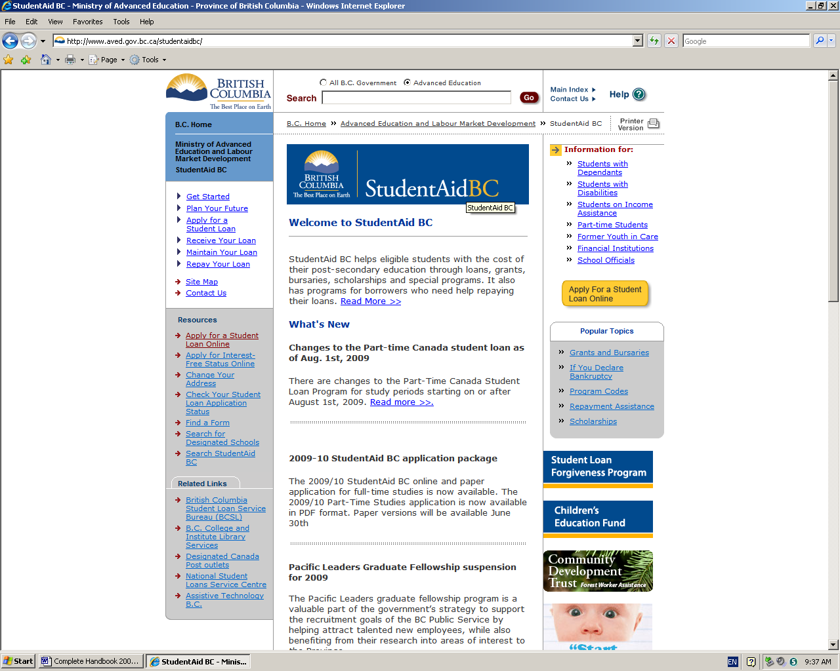

**http://www.aved.gov.bc.ca/studentaidbc/**

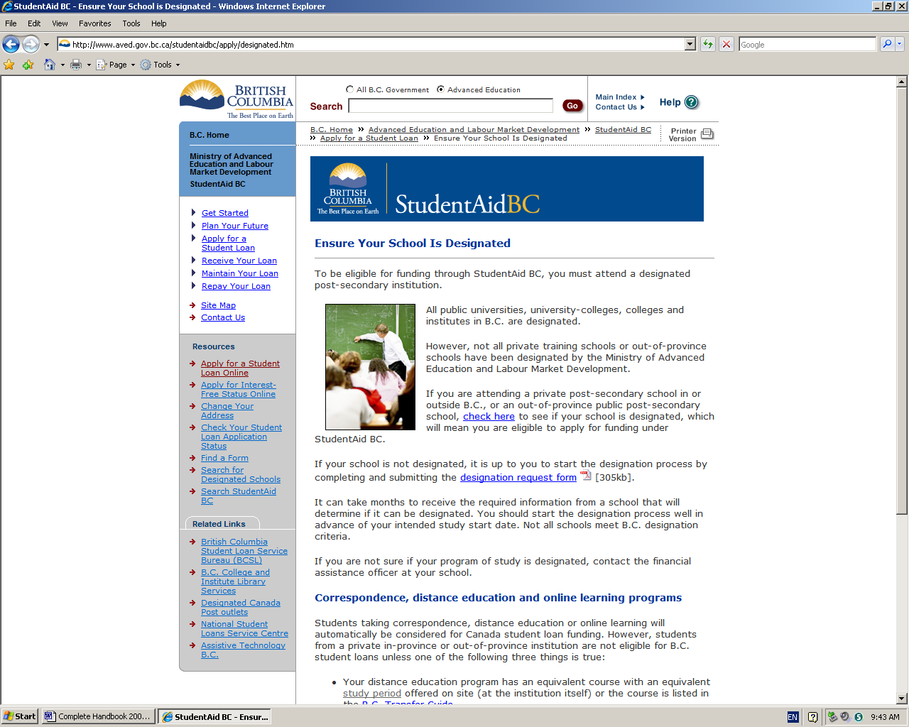

**http://studentaidbc/apply/designated**

SO02005_The Scholarship Resume

**Follow these steps in preparing the resume:**

**Part One:**

Brainstorm relevant data to complete each of the following categories:

* **Academic Achievements** - Include all awards (some may be discarded in the final copy but leave the options there by including everything). Include such things as Honour Roll standing , math or writing competitions, gifted classes, etc. Include your GPA if it is worth boasting.
* **Athletic Achievements** - Include all awards, team, organizing events, participation in solo and team events, MVP awards, etc.
* **Achievements in Visual and Performing Arts** - Music, dance, drama, art: give details such as roles, exhibitions, events, etc.
* **School Involvement** - Membership in Student Council, clubs, interest groups, peer tutoring, school volunteer experiences.
* **Community Involvement** - (outside school) Groups, scouting/guiding movement, church groups (choir, teaching Sunday School), interest groups (Sierra), volunteer work (candy stripers).
* **Conferences/Workshops** - Date, place, time, eg. Student Council Retreat, course related workshops eg. basketball workshop, theatre workshops.
* **Skills** - key boarding, languages, inter-personal communication, first aid certification eg. CPR.
* **Interests** - Anything which makes you an interesting person.
* **Work Experience** - Name and telephone number of your employers, most recent first plus a summary of your position and duties.
* **Career Plans** - Immediate and long term goals.

At this point do not worry about the order of the data and don't pre-judge the relevancy. Go as far back as Grade 10 and put the dates for each listing in parentheses (2006-07).

The Scholarship Resume

**Part Two:**

Order the data in each category.

* **Academic Achievements** - Most recent first. If more than one achievement in a given year, list the most important first. If some achievements span several years, eg. Honour Roll standing (2006-07). Put the longest term achievements which are still current first.
* **Athletic Achievements** - Group by sport or activity. Within each grouping, begin with the most recent achievement or activity.
* **Achievements in Visual and Performing Arts** - Group by category eg. Dance, Music, Drama. Within each grouping, begin with the most recent achievement or activity.
* **School Involvement** - Group by activity and within each activity, begin with the most recent involvement.
* **Community Involvement** - Group by activity and within each activity, begin with the most recent involvement.
* **Seminars, workshops, conferences** - Begin with the most recent.
* **Work experiences and employment** - Begin with the most recent.

**Part Three:**

* Eliminate data that falls into the "padding" category.
* Do not include anything in your scholarship resume that you would not be prepared to discuss intelligently at an interview.
* Interview questions are generally based on the information that you have included in your resume. Be prepared to discuss anything you have included.

**Part Four:**

* Format the resume.
* Get someone to proof read the resume.
* Submit the resume on time.

Good Luck! SO02005_

**What You Can Do to Help Your Children Succeed in College or University**

**1998 Dr. Marina Zinatelli, Pychologist**

Is it possible for parents to have constructive conversations with their children about school? Most parents would agree that it's often difficult if not impossible. Most would also agree that things are not getting better. As tuition costs increase and the notion of a "secure" career choice becomes more and more out of date, parents try harder and have less success helping their children cope with the new challenges that college or university education presents.

The good news is that there are things that parents can do to help. There is a growing body of information that deals with what helps people manage intellectually challenging tasks, cope with change, manage time, organize themselves, motivate themselves, manage stress and learn effectively. The following tips may help you feel a little less confused and frustrated in your efforts to support your children.

**Dos and Don'ts for Helping Your Children Succeed in College of University**

|  |  |
| --- | --- |
| **Do** | **Don't** |
| * express confidence in their abilities * respect their privacy * give positive feedback when they study * listen carefully to their concerns * celebrate large and small successes * show an interest in their goals * let them cope with disappointment * help create a good study location * ask how you can help * encourage them to access resources | * foster self-doubt and worry * pressure them for information * say "you should be studying now" * cut them off and interrupt * focus only on long-term outcomes * minimize what's important to them * say "I told you so" * expect them to study anywhere * provide help they may not want * ignore warning signs |

**Warning Signs**

Most students experience some kind of threat to their success at some point in their studies. The following are factors that tend to minimize the impact of these threats:

1. supportive parents/family

2. solid network of close friends

3. financial support

4. self-management and

5. study skills

Fortunately, these factors are not fixed and problems in any area can be addressed. It is best to foster these protective factors as much as possible to prevent problems from occurring and to pay attention to warning signs and act as soon as possible.

**Common Threats to Success and Resources for Help**

|  |  |
| --- | --- |
| **Threats** | **Resources** |
| * lack of interest in chosen field * too much time at part-time job * not enough time studying * trouble learning certain concepts * relationship breakup * trouble adjusting to university learning * illness * conflict with roommate * financial crisis * harassment * social isolation/home sickness | * interest testing * financial aid * study skills training * professor/teaching assistant/tutor * counselling * study skills/time management training * campus health services * residence administration * financial aid * harassment/equity officer * counselling/student clubs |

Although your children will have to face the challenge of succeeding in college or university in their own unique way, there are a number of things that you can do to help them succeed. Most campuses also offer a wide range of student services to ease the transition from high school to college or university and to support students until they complete their degrees.